Reading and Parsing data from Excel Forms

Contents

Sample input form: 2

Sample config file: 2

Advantages: 2

Disadvantages: 2

Output Data-table: 3

Code Flow: 3

Reading from excel files: 3

Manipulating data and inserting in data-table: 4

# Sample input form:



In the case of the above excel form, at a first glance the data might appear to be structured. When the developer tries to read the excel sheet and parse the data, several conflicts may arise regarding the coding logic and efficiency. Several nested for-each loops and if conditions might be required to fetch the data and put it into an easily parse-able format for e.g. a data-table. More ever the excel format might change which will change the coding logic drastically.

In-order to tackle the problem, a row-column, index based approach can be embraced.

# Sample config file:



The config file contains the cell indices (row, column values) corresponding to the cell coordinate where the value is located. The file also contains a column called ‘Field’ which contains the same values as the field names present in the input form.

## Advantages:

1. Easy referencing of the cell position containing a value.
2. Any changes in the input excel will not create a major code change as the new cell position needs to be changed only in the Config sheet. The code logic will traverse to the exact position and fetch the required values.
3. Any change in the field names doesn’t affect the output or the code present downstream.
4. Iteration helps us to reduce the code and prevents accessing the input form, multiple number or times.

## Disadvantages:

1. Mapping the indices (row, column values) might be a tedious task in instances when the fields are numerous.

# Output Data-table:



The above sheet contains the output data-table structure. The developer can use it as a template for the data-table. This makes it easy to maintain the data-table template as well and keeps it easily configurable.

# Code Flow:

## Reading from excel files:

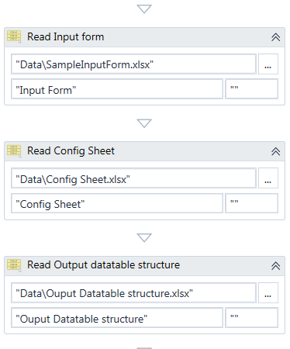

## Manipulating data and inserting in data-table:

